

**Department of Electrical & Computer Engineering**

**N**orth **S**outh **U**niversity

# PROJECT Title: ISA Design

**Course Code:** **CSE332**

**Course name: Computer Organization and Architecture**

**Section – 02**

**Summer 2022**

**Submitted to:** Dr. Tanzilur Rahman (TnR)

Assistant Professor,

Department of Electrical & Computer Engineering,

**N**orth **S**outh **U**niversity

**Submitted by:** Group Members

|  |  |  |
| --- | --- | --- |
|  | **Name** | **ID** |
| **1.** | Most Airin Akter | 1812770042 |
| **2.** | Anusree Roy | 2011364042 |
| **3.** | Nayeema Islam | 2031653642 |

**Introduction*:***

Our task is to design an ISA for a 10-bit RISC-type CPU.

**Objectives:**

We aim to design a 10-bit ISA that can solve particular problems, i.e., arithmetic operations, logical operations, branching, and handling loops. Here, we are going to show the detailed design of that ISA.

**How many Operands?**

* There are three operands, which we represented as **d**, **s, and t**.

**Type of Operands?**

* Register based
* Memory based

**How many Operations? Why?**

We allocated 4 bits for the opcode, so the number of instructions that can be executed is 2^4 or 16.

**Types of Operations?**

There will be, in total, five different types of operations. The categories are:

- Arithmetic

- Logical

- Data transfer

- Conditional Branch

- Unconditional Branch. There are 12 different operations. The details are given below:

|  |  |  |  |  |  |
| --- | --- | --- | --- | --- | --- |
| **Category** | **Instructions** | **Syntax** | **Meaning** | **Format** | **Opcode** |
| Arithmetic | Add | add $s0, $s1 | $s0 = $s1 + $s0 | R | 0000 |
| Subtract | sub $s0, $s1 | $s0 = $s1 - $s0 | R | 0001 |
| Add Immediately | addi $s0, offset | $s0 = $s0 + constant | I | 0010 |
| Logical | AND | and $s0, $s1 | $s0 = $s0 & $s1 | R | 0011 |
| OR | or $s0, $s1 | $s0 = $s0 | $s1 | R | 0100 |
| NOR | nor $s0, $s1 | $s0 = ~($s0 | $s1) | R | 0101 |
| Conditional  Branch | Branch on equal | beq $s0, target | If ($s0 == $s1)  Go to the target address | I | 0110 |
| Branch on not equal | bne $s0, target | If ($s0!= $s1)  Go to the target address | I | 0111 |
| Set on less than | slti $s0, offset | If ($s0 < constant) $s3=1;  Else $s3= 0; | I | 1000 |
| Unconditional  Jump | Jump | j target | Jump to the target address | J | 1001 |
| Data Transfer | Load word | lw offset($s0) | $s1 = Memory[$s0 + constant] | I | 1010 |
| Store word | sw offset($s0) | Memory[$s0 + constant] = $s1 | I | 1011 |
| In | din $s0 | $s0 = User Input | R | 1100 |
| Out | dout $s0 | System Output = $s0 | R | 1101 |

**Instruction Description:**

add: It adds two registers and stores the result in the destination register.

∙        Operation: $s0 = $s0 + $s1

∙        Syntax:  add $s0, $s1

sub: It subtracts two registers and stores the result in the destination register.

∙        Operation: $s0 = $s0 - $s1

∙        Syntax: sub $s0, $s1

addi: It adds a value from the register with an integer value and stores the result in the destination register.

∙        Operation: $s0 = $s0 + offset

∙        Syntax: addi $s0, offset

and: AND’s two register values and stores the result in the destination register. It sets some bits to 0.

∙        Operation:  $s0 = $s0 && $s5

∙        Syntax: and $s0, $s5

or: It OR’s two register values and stores the result in destination register. It sets some bits to 1.

∙        Operation:  $s0 = $s0 || $s5

∙        Syntax: or $s0, $s5

nor: It NOR’s two register values and stores the result in the destination register. Sometimes, we use nor to get NOT of register value.

∙        Operation:  $s0 = $s0 nor $s1

∙        Syntax: nor $s0, $s1

beq: It checks whether the values of two registers are same or not. If it’s the same, it operates the address at offset value.

∙        Operation: if ($s0==$s6) jump to offset

else goto next line

∙        Syntax: beq $s0, offset

bne: It checks whether the values of two registers are the same or not. It operates the address at offset value if it's not the same.

∙        Operation: if ($s0!=$s6) jump to offset

else goto next line

∙        Syntax: bne $s0, offset

slti: If $s0 is less than offset, $sp is set to one. It gets zero otherwise.

∙        Operation:   if $s0 < offset $s3= 1

else $s3 = 0

∙        Syntax: slti $s0, offset

lw: It loads a required value from the memory and writes it back into the register.

∙        Operation: $s1 = MEM[$s0 + offset]

∙        Syntax:  lw offset($s0)

sw: It stores specific values from register to memory.

∙        Operation: MEM[$s0 + offset] = $s1

∙        Syntax:   sw offset($s0)

J: Jumps to the calculated address.

∙        Operation: PC = nPC

∙        Syntax: j target

**5. How many Formats?**

We want to use two formats for our ISA.

Register type – (R-Type)

Immediate Type – (I- Type)

We don't need J type format since Jump operation can be done in I type format by keeping rs, rt null.

*R-Type ISA Format:*

|  |  |  |  |
| --- | --- | --- | --- |
| **Opcode** | **rs** | **rt** | **rd** |
| 4 bits | 2 bits | 2 bits | 2 bits |

*I-Type ISA Format:*

|  |  |  |  |
| --- | --- | --- | --- |
| **Opcode** | **rs** | **rt** | **immediate** |
| 4 bits | 2 bits | 2 bits | 2 bits |

**List of Registers:**

We’ve used 6 registers and assigned 2 bits for each of the registers. The Register we have selected are given below:

|  |  |  |  |
| --- | --- | --- | --- |
| **Register Number** | **Register Name** | **Registers in binary** | **Comment** |
| $0 | $zero | 00 | This register contains 0. |
| $1 | s1 | 01 | General purpose register. Used for storing address/data |
| $2 | s2 | 10 | General purpose register. Used for storing address/data |
| $3 | s3 | 11 | General purpose register. Used for storing address/data |

**Addressing Modes:**

Each format can have at least one addressing mode. There is only one addressing mode for the R-type format: register addressing. I type format has two addressing modes: immediate and base addressing.

**Register Addressing:**

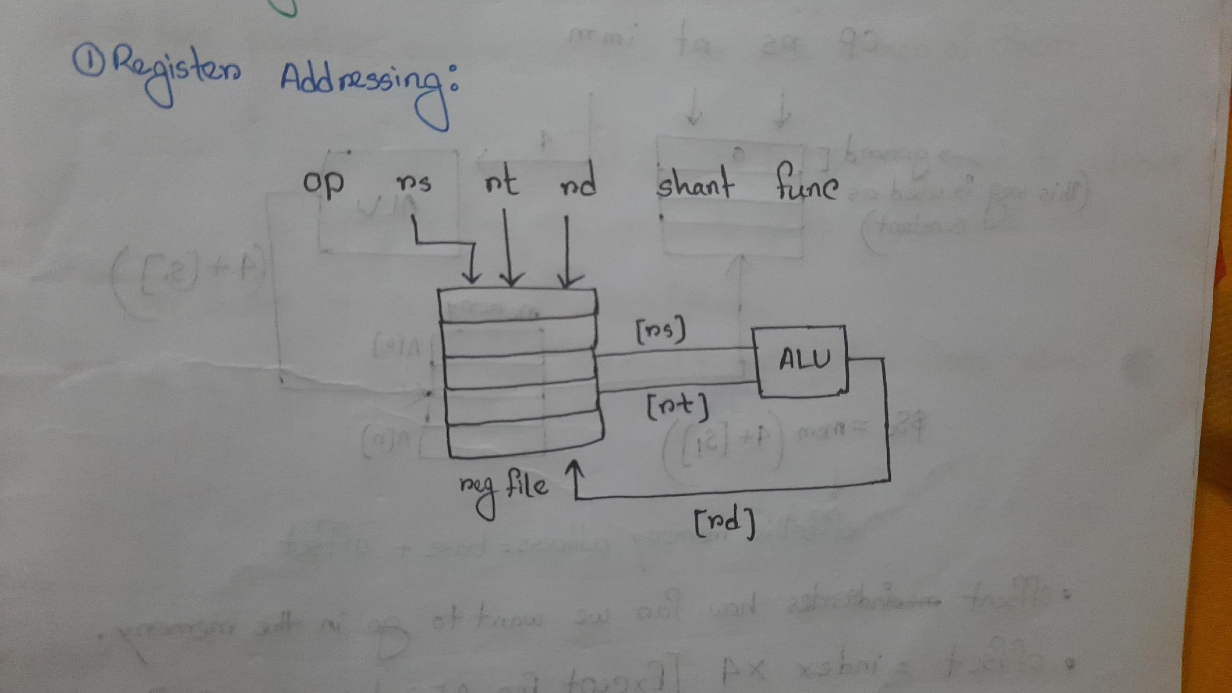

**Immediate Addressing:**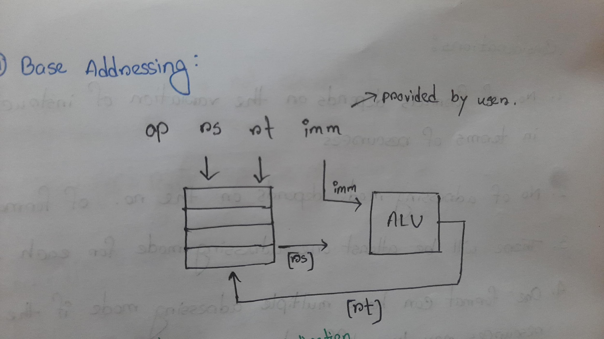

**Base Addressing:**

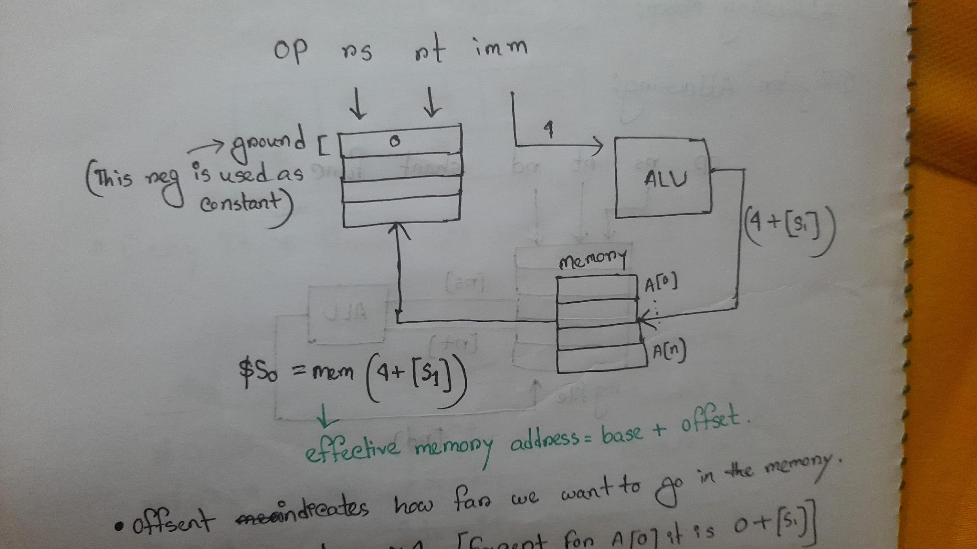

**Translating Some HLL codes using our Designed 10-bit ISA:**

**Arithmetic Operations:**

[Assume b is in $s1, d is in $s2, k is in $s0]

1. k = b + d

**add $s0, $s1, $s2**

1. k = b – d

**sub $s0, $s1, $s2**

***Logical Operations:***

[Assume a is in $s1, b is in $s2, k is in $s0]

1. k = a AND b

**AND $s0, $s1, $s2** //$s0 gets $s1 AND $s2

1. k = a OR b

**OR $s0, $s1, $s2** //$s0 gets $s1 AND $s2

***Data Transfer Operations:***

[Assume i is in $s1, A is in $s2, g is in $s0]

g = A[i]

**sub $s0, $zero, $zero** //initialize $s0=0 to move data into $s0

**add $s1, $s1, $s2**  // here $s1 = i, so it becomes 2i

**add $s1, $s1, $s1** // 2i +2i= 4i

**add $s1, $s1, $s2**

**lw $s0, 0($s1)** // here we stored the value of A[i] in $s0

***Conditional Operations:***

[Assume i is in $s1, j is in $s2]

1. if ( i == j ){ **beq $s1, $s2, L**

i = i+1; **addi $s1, $s1, -1**

} else { **jmp exit**

i = i-1; L: **addi $s1, $s1, 1**

} **jmp exit**

**exit:**

assume i is in $s1, j is in $s2

1. if ( i <j) {

i = i+1;

} else {

i = i-1**;**

}

**slt $s0 , $s1 , $s2**

**beq $s0 , $zero , L**

**addi $s1, $s1, 1**

**jmp exit**

**L: Addi $s1, $s1, -1**

***Loop Type Operations:***

[Assume i = *$s0,* x = $s1]

(i) for (int i = 0; i < 5; i++) {

x=x*2;

}

1. **add $ s0 , $zero , $zero**
2. **L : slti $s0 , $s0 , 5**
3. **beq $s0 , $zero , Exit**
4. **add $s1, $s1 , $ s1**
5. **Addi $s0 , $s0 , 1**
6. **jmp L**
7. **Exit**

**Limitations we have:**

1. In this 10-bit CPU, only 12 operations were used; at maximum, 14 operations can be used.
2. For bit limitation, the CPU did not use the ‘Function’ and ‘Shift amount’ of R-type instruction. Instead, the instructions were passed to the Opcode portion of the ISA.
3. This CPU doesn’t have any error-handling functionalities; thus, the user must have valid instructions in the correct order supported by the CPU.
4. We have limited bits in R-type format. Therefore, we cannot perform logical operations like sll and srl. Since we cannot perform sll and srl, we used these two operations by manipulating add and sub.
5. We cannot perform immediate operations whose size is more significant than 2^2 = 4 bits.